FRIENDS AND FAMILY TEST
Results for March 2024

Thank you to all the patients who completed a friends and family test survey in March 2024.

- How likely are you to recommend our practice to family and friends if they needed similar care or treatment?
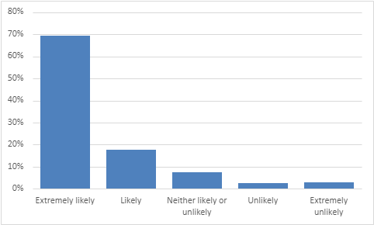
69% are extremely likely to recommend the practice.
18% are likely to recommend the practice.
7% are neither likely nor unlikely to recommend the practice.
3% are unlikely to recommend the practice.
3% are extremely unlikely to recommend the practice.

- If we could change one thing about your care or treatment, what would it be?
- Nothing at all. Everything was excellent.
- Best service I have ever had at a doctor’s surgery.
- I am very happy with my care and the practice.
- Dr Brown was very good, just said what needed to be said, no nonsense. Much appreciated.
- Dr Hart was fantastic.
- Nurse Carol is amazing. She always puts me at ease.
- Both Tracey and Dr Challa were very helpful. Dr Challa is very good.
- Gemma is particularly helpful and goes out of her way to assist.
- Jean is amazing. Jean is so lovely.
- The nurse was amazing, so friendly. The nurse was brilliant and very professional.
- Tracey Gallery, professional, caring and efficient. Could not ask for better.
- Lovely staff especially Sue who is always extremely helpful and polite.
- Your office staff are amongst the most friendly and helpful I have ever dealt with.
- Quicker appointments and more face to face appointments.
- Go back to being able to make appointments over the telephone.
- You need to listen.
- New booking system no good for blind and elderly people.
- Have an effective customer focus, the surgery is run for the benefit of the patients.
- The booking process was very difficult. Make the appointment system more user friendly.

